**Project Design Phase-II**

**Data Flow Diagram & User Stories**

|  |  |
| --- | --- |
| Date | 03 October 2022 |
| Team ID | PNT2022TMID51719 |
| Project Name | Smart Farming-IOT Enabled smart farming application |
| Maximum Marks | 4 Marks |

**Data Flow Diagrams:**

A data flow diagram (DFD) maps out the flow of information for any process or system. It uses defined symbols like rectangles, circles and arrows, plus short text labels, to show data inputs, outputs, storage points and the routes between each destination. Data flowcharts can range from simple, even hand-drawn process overviews, to in-depth, multi-level DFDs that dig progressively deeper into how the data is handled. They can be used to analyze an existing system or model a new one. That’s why DFDs remain so popular after all these years. While they work well for data flow software and systems, they are less applicable nowadays to visualizing interactive, real-time or database-oriented software or systems.

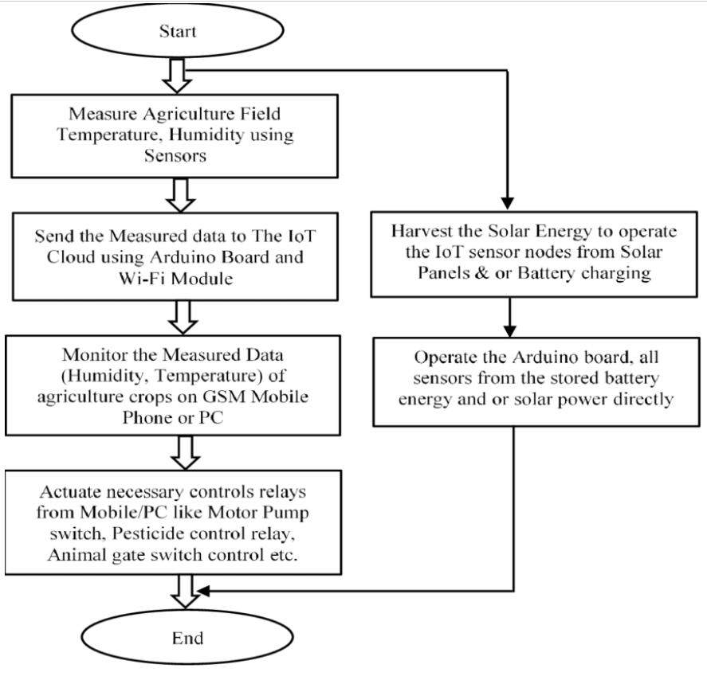

**FLOW**

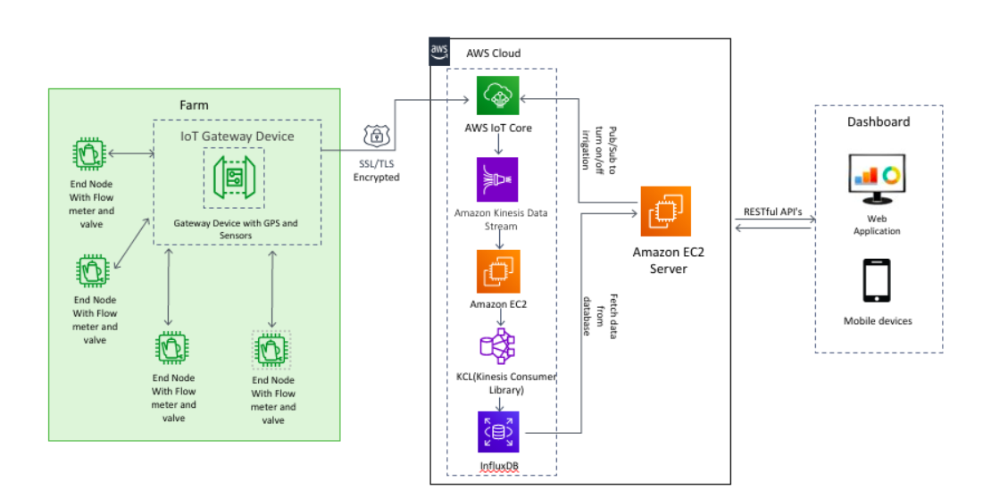

**User Stories**

| **User Type** | **Functional Requirement (Epic)** | **User Story Number** | **User Story / Task** | **Acceptance criteria** | **Priority** | **Release** |
| --- | --- | --- | --- | --- | --- | --- |
| Customer(Mobile user) | Registration | USN-1 | As a user, I can register for the application by entering my email, password, and confirming my password. | I can access my account / dashboard | High | Sprint-1 |
|  | Permission | USN-2 | As a user, I will receive confirmation email once I have registered for the application | I can receive confirmation email & click confirm | High | Sprint-1 |
| Customer (webuser) | Login/App | USN-3 | As a user, I can log into the application by entering email & password | I can register and access the dashboard with login | High | Sprint-1 |
|  | Dashboard | USN-4 | As a user, I can able to learn how to access the application. | Important information other than profile | High | Sprint-1 |
| Customer (Gadget User) | Monitoring of climatic condition | USN-1 | As a user, I can use gadgets which are weather stations, combining various smart farming sensors measurements can be used to map the climate conditions. | Temperature and climate detail | High | Sprint 1 |
|  | Agricultural drones |  | Agri -tech advancements is the use of agricultural drones in smart farming. drones are better equipped than airplanes and satellites to collect agricultural data. Apart from surveillance capabilities, drones can also perform a vast number of tasks that previously required human labor: planting crops, fighting pests and infections, agriculture spraying, crop monitoring, etc. | console | Medium | Sprint 2 |
|  | Greenhouse automation | USN-1 | Farmers use manual intervention to control the greenhouse environment. The use of IoT sensors enables them to get accurate real-time information on greenhouse conditions such as lighting, temperature, soil condition, and humidity. |  | Low | Sprint 3 |
| Customer Care Executive | Log out |  | Exit | Sign out | High | Sprint 1 |